Introduction to ITWS

Quiz 1: March 1, 2018

There are 5 questions of multiple parts. Point values and suggested times are indicated

Place your name on the top of the document in the header

Enter your answers directly into this document (with the exception of #2)

All answers should be in be in Your Own Words, and use proper grammar

Make sure your answers use an alternative font and/or color

Save the document as *yourname*-quiz1.docx (or doc)

Place all documents including this one in a folder named

ITWSQuiz1-*yourname*-*yourRCSID*

When finished with the quiz, zip your folder and all related files into a file named

ITWSQuiz1-*yourname*-*yourRCSID*.zip

And submit it to LMS

Follow all of these instructions or you will lose points

1. Network protocols, HTML & WWW : (20 points, 10 minutes)  
   1. Explain how the OSI 7-layer model is relevant to me searching the answer to this question on Google. (5 points)

The OSI 7 layer model is a model of communication over the web that illustrates the process in 7 stages.

Using the simplified model that we discussed in class that combines the application, presentation, and session stage into one and also combines the data link and physical stage into one, here is how googling something would be illustrated.   
  
In the first stage on the client side, the application layer, my web browser would use HTTP to send a request to google asking for search results.

In the next stage, the transport layer, the TCP protocol would first establish a connection with the outgoing server via the three way handshake (1. SYNC from client, 2. SYNC + Acknowledge from server, 3. Acknowledgement from client).

From there, the IP / Internet layer assigns my request an IP address than routes it to the appropriate server

Finally, the link layer sends the data.

This process happens in reverse on the other end (the outgoing server), then sends a response back that contains the information requested.

* 1. What is a VPN. Why do we need/use it (give an example)? (5 points).

A VPN is a virtual private network. It functions by using encryption and tunneling protocols to connect to a remote network which then fetches resources from the internet and serves them back to the original user of the VPN. VPN’s are useful for masking one’s location. Since they use another network as an intermediary to connect a user to the internet, it will appear as if the user has the VPN’s IP address rather than the IP address that they were originally assigned.

* 1. Explain the difference between a GET and a POST request, and give specific examples of their use? (5 points)

GET requests are more common and simpler. They are typically used to request resources from a server (example would be clicking on a hyperlink that serves another webpage) and thus the body of the request is empty. POST requests are more complicated and are often used to submit data (example would be submitting an HTML form). In a POST request, the request body has lots of different headers to specify parameters about the data being submitted.

* 1. What is the difference between an IRI and a URI and describe a URI’s format in detail as covered in class? (5 points)

IRIs and URIs are both strings of characters used to identify a resource on the web. IRIs are similar to URIs, but while URIs are limited to the ASCII character set, IRIs are able to use Unicode characters to represent strings that may include Chinese, Japanese, or other non western languages.

1. HTML & CSS (40 points, 20 minutes)

Instructions to this question are contained in the HTML file in the zip folder you downloaded from LMS.

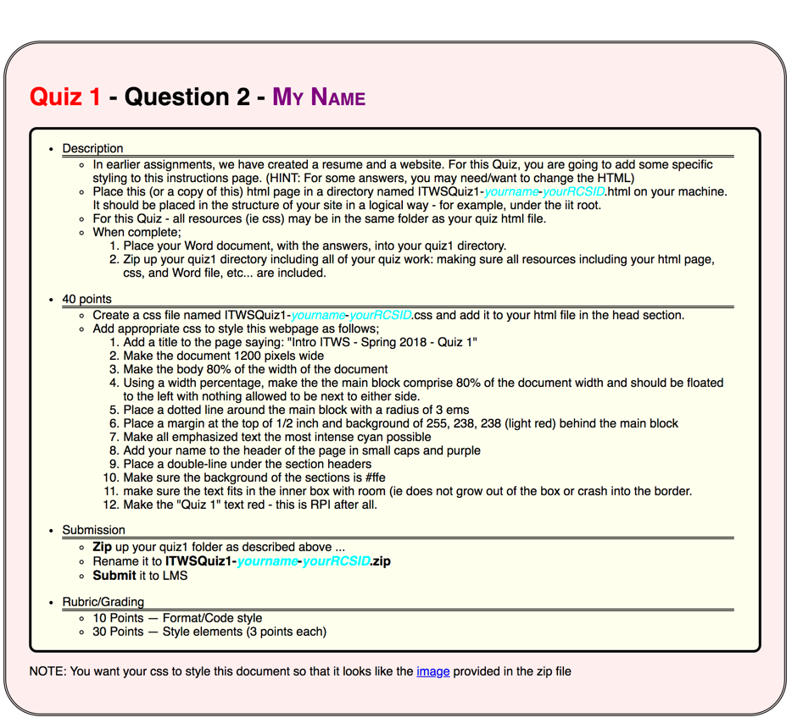

1. Communications and Networks. (20 points, 10 minutes)
   1. What is the Value of a network? What is the cost of a network? How do they relate? (Answer in complete sentences) (10 points)

The value of a network is given by Metcalfe’s Law which states that the value of a network is determined by the number of connections in the network which is proportional to the square of the number of users. Basically, Value = O(N^2). The cost of a network is proportional to the number of users on the network. The cost only scales linearly because it is assumed that the cost of expanding infrastructure to handle more users is constant. The number of connections in a network scales exponentially, because every new user can theoretically become connected to every previous user.

* 1. As discussed in class: What is Time Division Multiplexing? Why is it useful? (Answer in complete sentences) (10 points)

To make use of limited bandwidth on a network (i.e. only so many fiber optic cables or mbps allowed), time division multiplexing allocates independent users slots of time where the network handles their communications – e.g. two users will be alternatingly served by the network every other second. Under this scheme, a single cable can handle multiple channels and serve many users which is obviously a useful way of making the most of limited resources.

1. Web Science Guest Lecture (10 points, 10 minutes)
   1. What is Web Architecture? What are 3 related core standards (Answer in complete sentences) (5 points)

Web architecture refers to the systems of the internet that have established standards for identifying, representing, and exchanging data via the web.

3 Relevant core standards include: URIs (the standard for identifying resources), HTML (the standard for representing data located on the web in a human digestible form), and HTTP (a standard set of protocols for transferring data across the web).

* 1. Name at least three core principles for creating a healthy web. Why is Linking important? (Give an example) (Answer in complete sentences) (5 points)

Some core principles for creating a healthy web include one: an emphasis on URIs clear representing tangible things; two: URIs accessed via HTTP returning informational that’s useful and relevant; and three: URIs linking to other, related URIs. The third principle, linking, is especially important because it can serve as a metric for the overall quality of a resource identified by a URI. If a URI is linked to by others a lot, it implies that that URI is considered particularly useful.

1. “Facebook Fake News in the Post-Truth World” Case (10 points, 10 minutes)  
   1. What are network effects? Why are network effects crucial to the success of a social networking platform? (5 points)

Network effects get back at Metcalfe’s Law. They refer to the increasing benefits that accrue when more people join a network. This is because every new user can be potentially connected to all previous users, so the number of connections / interactions / benefits increasing exponentially in comparison to the number of users on a network.

This is what allows social media platforms to become so successful. The more people are on a platform, the more potentially positive interactions a user can have which would cause them to continue using the site. The more people that are on a platform, the more likely it is that a user’s friends are also using that platform, which would encourage them to join. The theory behind networks allows these platforms to quickly accrue benefits which allows them to more easily gain users which are vital to the platform’s success.

* 1. If you were to start a social networking platform tomorrow, what would your plan be for generating revenue? Why? (5 points)

As we discussed in class, it is relatively simple to startup a new social networking platform. I could take out a small loan and hire some programmers to quickly develop a rudimentary interface.

From there, it becomes a question of outcompeting the competition. Disregarding all ethics and focusing solely on revenue, I suppose I’d want to quickly attract users to the site by offering them content that appeals to their interests and preexisting beliefs. Users like being proven right, so this would make my site more appealing. Content that incites strong reactions is also a plus, as those reactions gain more publicity for my site. From there, if all goes according to plan, I could gain revenue by offering targeted advertisements to the users of my site. If my site became popular enough I could also take the snapchat route and totally redesign my interface to favor corporate sponsors and generate more ad revenue. Users may be upset, but if my platform is the most widely used / only thing of its kind, they would have no choice but to continue using it.